Taylor Cowley

Lab 10: Designing the LC3 Datapath (LC3 Functional Units)

Why do these labs have 2 separate titles?

June 13 2016

EAB Verilog file

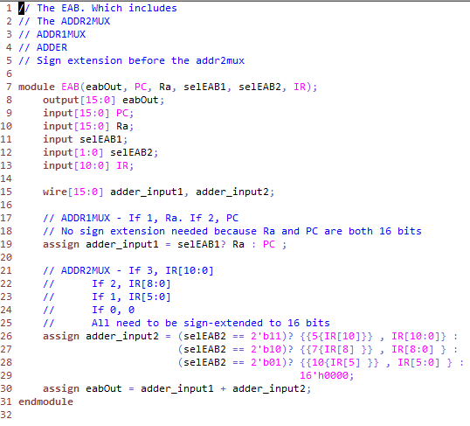

EAB Simulation waveform

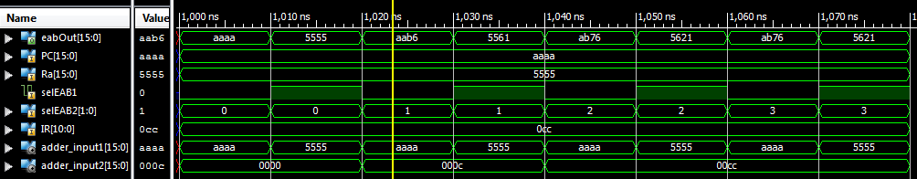

MARMux Verilog file

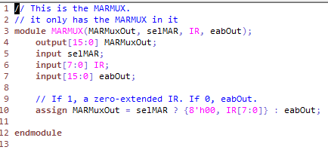

MARMux Simulation waveform

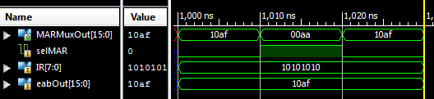

PC Verilog file

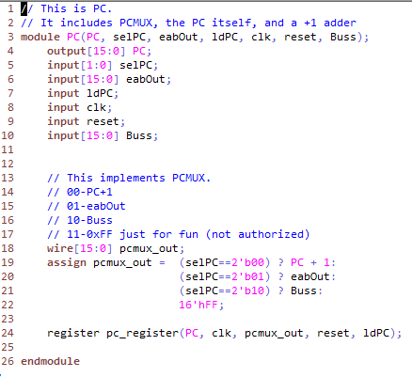

PC Simulation waveform

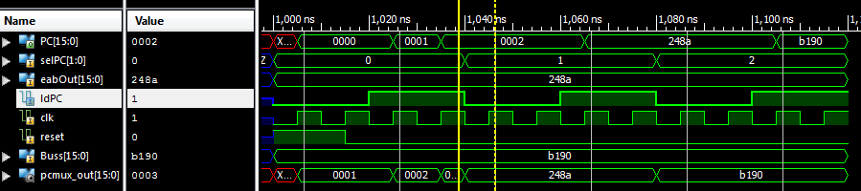

IR Verilog file

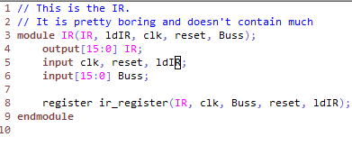

IR Simulation waveform

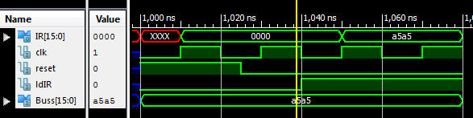

NZP Verilog file

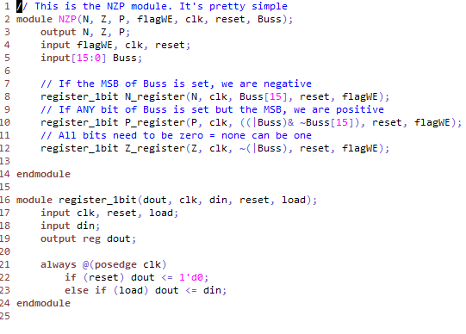

NZP Simulation waveform

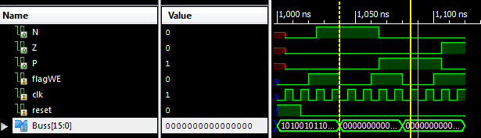

ALU Verilog file

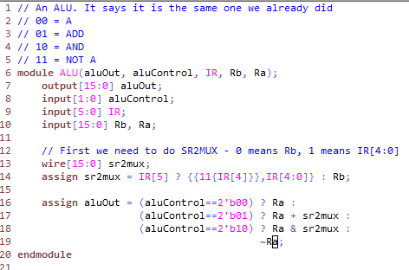

ALU Simulation waveform

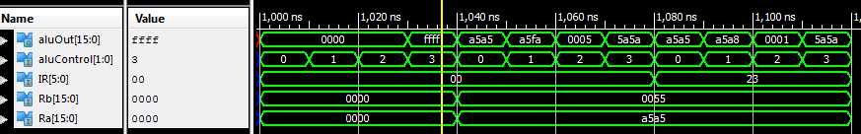

ts_driver Verilog file

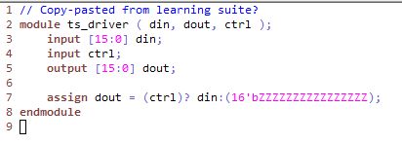

ts_driver Simulation waveform

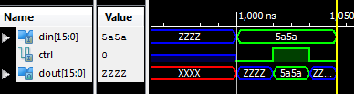

RegFile Verilog file

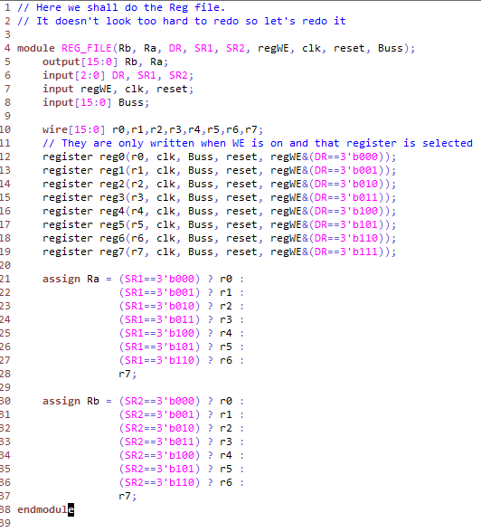

RegFile Simulation waveform

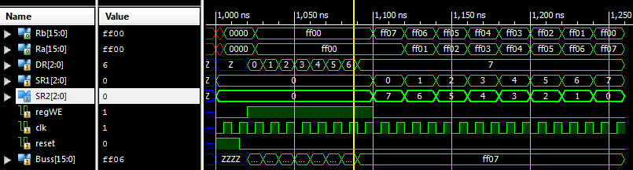

**Anomalies (bugs, problems, and suggestions)(5pts possible)**

So just realizing that I had to trust the basic modules- they aren’t doing anything special! Then it was easy to code up. And VIM is much nicer to code Verilog into than the Xilinx editor. In case you were wondering.